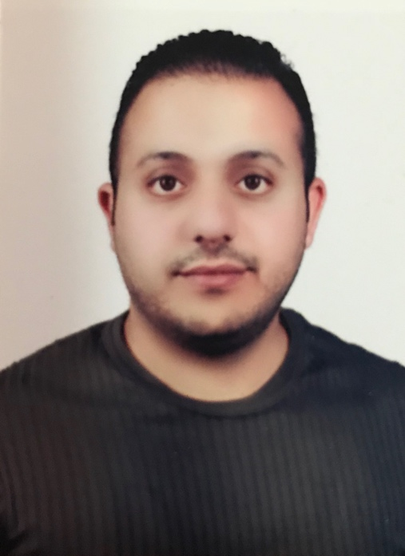

|  |
| --- |
| curriculum vitae |

|  |
| --- |
| Personal information |

|  |  |  |
| --- | --- | --- |
| Name |  | **Hisham Muhammad Sabri** |
| Address |  | **Baghdad / Hay Al-Yarmouk** |
| Mobile |  | **+964-7901391437** |
| E-mail |  | **hisham.m.sabri@gmail.com** |
| Nationality |  | **Iraq** |
| **Date & place of birth** |  | **[13-01-1983]-Baghdad/Iraq.** |
| **Marital Status** |  | **Married** |
| **University** |  | **University of Al- Mustansiraya, College of Arts/ Dept. of English Language Translation (Bachelor Degree)** |

|  |
| --- |
| **Work Experience** |

|  |  |  |
| --- | --- | --- |
| **•** Dates (from – to) |  | 2012 Sep till Dec 2017 |
| **•** Name and address of employer |  | Nokia Solutions Networks- Al-Mansur-609/1/46-Baghdad-Iraq |
| **•** Type of business or sector |  | Mobile Telecommunication Services |
| **•** Occupation or position held |  | Accounting |
| **•** Main activities and responsibilities |  | * SAP tool Skilled User, reporting. * SOX Controls maintaining on monthly basis. * Cash control that includes cash withdrawal deposit and petty cash and maintain monthly report in this regard. * Fully maintaining company bank accounts and required reporting accordingly. * Employees’ payroll and expenses claims processing. * Inter-logistics financial processing and reporting using SAP P66 and P20. * Initiating/attending monthly local financial strategy review. * Member of project Finance and Control team to facilitate project mangers’ approval. * creating vendors' related purchase orders using a system named MyOrders as a major part of procurement work and educating non-financial staff how to be familiar with MyOrders to make sure that order requests goes smoothly with no delay also monitor these POs till they are fully delivered to book their GRs and move them to the record files. * Employees monthly social security contributions payments initiating, processing and finalizing in addition to fulfilling all other social security procedures. * Employees’ monthly **PIT** contributions payments initiating, processing and finalizing in addition to fulfilling all other **PIT** procedures. * Online banking experiences including payments’ initiating, processing, bank statements extracting and FX deals processing. * Prepare monthly reporting and bank accounts reconciliations to be forwarded to treasury dept. |

|  |
| --- |
| **Work Experience** |

|  |  |  |
| --- | --- | --- |
| **•** Dates (from – to) |  | 2011 Nov till Sep 2012 |
| **•** Name and address of employer |  | Zain Iraq- Al-Mansur-609/1/34-Baghdad-Iraq |
| **•** Type of business or sector |  | Mobile Telecommunication Operator |
| **•** Occupation or position held |  | Customer Care Representative (CCR) |
| **• Main activities and responsibilities** |  | Receiving customers’ complaints calls and try to solve the issues initially or forward them to relevant Dept.  This process involves using professional tools and programs in addition to Microsoft office. |

|  |
| --- |
| **Work Experience** |

|  |  |  |
| --- | --- | --- |
| **•** Dates (from – to) |  | 2005 Oct till Nov 2011 |
| **•** Name and address of employer |  | Ministry of Finance -Baghdad-Iraq |
| **•** Type of business or sector |  | Industrial Bank of Iraq |
| **•** Occupation or position held |  | Translator / Accounting |
| **•** Main activities and responsibilities |  | * Six years of experience in different bank's departments. * Dept. of investment, Translates the contracts and essays also working as negotiator in addition to data entry and redistribution after each Capital increase for own organization and customers' organizations. * Current accounts and savings, Incomings and expenses, current/ deposit account dealer, investment and stock exchange * Dept. of Credit and Credit info data entry and control for clients credit info. * Dept. of Finance Operations, authorized RTGS approver * Dept. of Management, HR specialist |

|  |
| --- |
| **Languages** |

|  |  |  |
| --- | --- | --- |
| **Mother tongue** |  | **(Arabic)** |
| Other languages |
|  |  | **[ English ]** |
| **•** Reading skills |  | [Indicate level: excellent, good, basic.] : [excellent] |
| **•** Writing skills |  | [Indicate level: excellent, good, basic.] : [excellent |
| **•** Verbal skills |  | [Indicate level: excellent, good, basic.] : [excellent] |

|  |  |  |  |  |  |  |  |  |  |  |  |  |  |  |  |  |  |  |  |  |  |  |  |  |  |  |
| --- | --- | --- | --- | --- | --- | --- | --- | --- | --- | --- | --- | --- | --- | --- | --- | --- | --- | --- | --- | --- | --- | --- | --- | --- | --- | --- |
| **Software skills**  **and Competence** |  | |  |  |  |  |  |  | | --- | --- | --- | --- | --- | --- | |  | Word | Excel | Outlook | Power Point | Visio | | Excellent | ☺ |  | ☺ |  |  | | Good |  | ☺ |  |  |  | | Basic |  |  |  | ☺ | ☺ | |

|  |  |  |  |  |
| --- | --- | --- | --- | --- |
| **Reference** | Name | University/Company | Title | Email |
| Atif Ali | Nokia solutions Network | Iraq Branch Finance & Control Manager | Mobile: +964 7509154786  atif.ali@nokia.com |
| Mohamed Aziz | Nokia solutions Network | Iraq Branch Director | Mobile: +44 7990 614 891  [mohinbath@gmail.com](mailto:mohamed.1.aziz@nsn.com) |